Screening for resistance to the banana weevil (Cosmopolites sordidus)
G. Mwanje and G. V. Nakato*
September 2021

International Institute of Tropical Agriculture (IITA) Uganda office; Plot 15B, East Naguru road; P.O. Box 7878; Kampala, Uganda
*Correspondence: V.Nakato@cgiar.org

Introduction
Banana weevils are a very important pest, besides nematodes, that contribute to decline in production and disappearance of bananas in some regions of Uganda (Gold et al., 1993). This pest can cause yield loss ranging from 5% in the first cycle to 40% in the fourth ratoon cycle (Rukazambuga et al., 1998). However, loss of up to 100% can also be obtain starting from the fourth ratoon cycle (Sengooba, 1986; Gold et al., 2004). This is because banana weevil populations build up slowly but exponentially over the years (Rukazambuga, 1996), therefore the damage is often greatest as the crop ratoon increases (Mitchell, 1980). The damage caused by weevils is a result of the larvae feeding on the corm, hence weakening the plant, creating wounds from which secondary pests and fungi access the inner parts thus destructing and decomposing the rhizome tissues (Rukazambuga et al., 1998). This can later result into premature death of the plant, snapping of the corm, reduced bunch weights and reduced banana standing life (Gold et al., 2001).
The measures used to control banana weevil’s damage vary widely depending upon the type of banana production systems practiced (Padmanaban and Sathiamoorthy, 2001). One of the control measures is the use of chemicals (Masanza, 2003), mainly under commercial production (Gold and Messiaen, 2000).Cultural control strategies are also being applied and they are of greater significance to resource-limited farmers cultivating banana for subsistence production (Padmanaban and Sathiamoorthy, 2001) and these practices include planting of clean planting material coupled with improved agronomic practices so as to increase the plant vigor and proper field sanitation through proper management of crop residues (Gold et al., 2001). Some biological control measures have been applied and these involve the use of exotic natural enemies, endemic natural enemies, secondary host associations, and microbial control for example entomo-pathogens, endophytes and entomo-phagous nematodes (Gold et al., 2001). However, biological control is difficult due to the weevil’s boring habit (Gold et al., 2001), and methods like use of entomo-pathogenic fungi as biopesticides may not be affordable by most farmers (Tinzaara et al., 2009).
The available biological control measures of banana weevils using natural enemies has so far been unsuccessful (Gold et al., 2001). Germplasm improvement to develop resistant cultivars is the most sustainable solution towards control of banana weevils (Tinzaara et al., 2009), especially in developing countries where farmers lack the resources for other control measures (Frison, 1999). However, the genotypes used in the banana improvement for weevil resistance need to be evaluated for resistance against banana weevils. Banana being a long cycle crop, field screening for weevil resistance takes long (Kiggundu et al., 2000). It is also labour intensive and require large space as each banana plant occupies 4m² to 9 m² depending on the planting density (Sadik et al., 2010). Therefore, this standard operating procedure is developed to provide guidance when evaluating for weevil resistance among the genotypes to be used in the banana breeding program in a reliable and time saving manner.

Materials and methods
Plant materials
- TC generated plant material including:
- Test genotypes (Parental genotypes and newly developed hybrids)
- Resistant checks:
  - Calcutta 4
- Land race controls:
- Mchare
- Mbwazirume
- TM-28 OBINO LEWAI
Other materials
- Sterile forest soil
- Sterile sand
- Weevil proof nets
- 13-liter plastic pots
- Watering cans
- Weevils
Multiplication, weaning, and transplanting of tissue culture plantlets
- Genotypes from the tissue culture laboratory are left in the nursery under humid chamber for 4 weeks and later harden under shade in the nursery for four more weeks
- After hardening off, genotypes are planted in 13-litre volume plastic buckets that are filled with a mixture of sterilized topsoil, farm manure and saw dust in the ratio of 3:1:1 respectively.
- Buckets are then sealed off with weevil poof nets to prevent weevils from the nearby fields from entering them, the bucket are then organized according to the design in open space under shade (Fig. 1).
- Genotypes are allowed to establish themselves for three months in order to attain a suitable corm size before the introduction of weevils.
- Watering is done regularly to enable the establishment of the suckers.
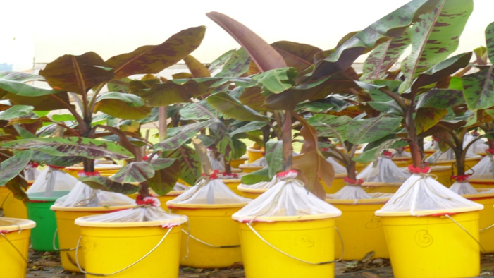
Figure 1. Established potted trial to evaluate genotypes for weevil resistance

Experimental design
Parental genotypes
Partially replicated experimental design (P-Rep) with three blocks will be adopted with each parental genotype occurring in duplicate and the checks in triplicate for the entire experimental set up. Each plot will constitute four plants per genotype. P-rep designs are useful when plant materials and space are limiting factors. In fact, P-rep designs allow for repeated trial evaluations at different locations. The experimental design for the available 31 parental genotypes including checks is shown in Table 1 below. The average efficiency 0.98 indicating that the design is optimal.
Table 1. P-rep lay out for banana weevil screening for the available 51 parental lines including checks
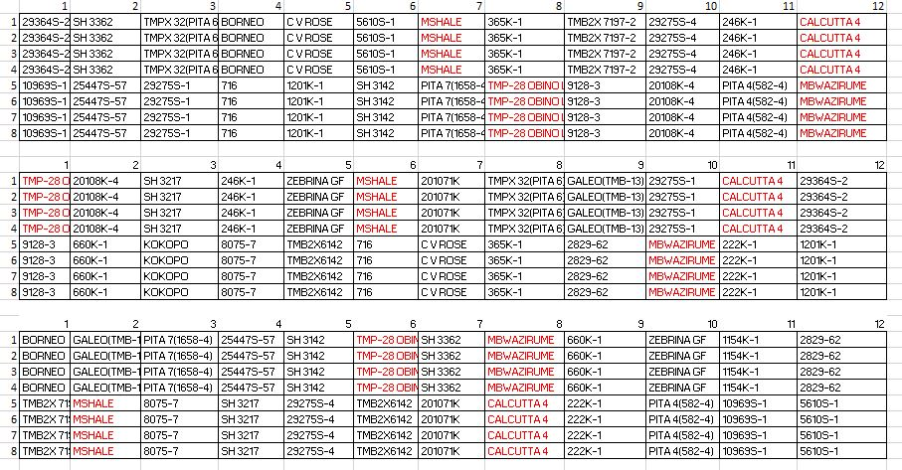
Note: Names in black colour used in the blocks are the parental genotypes to be screened, and those in red colour are for the checks and controls in each block.

Hybrid genotypes
The augmented design resulting into an incomplete block design where standard checks are replicated in each block and test genotypes will not be adopted for the hybrids. Such augmented designs are very useful where very large numbers of hybrids are produced with limited planting materials and reduced space.
Collection and rearing of banana weevils
- Banana weevils are collected from the old, infested banana plantations using pseudo stem traps.
- The pseudo stems are cut into pieces of about 30cm long and then split into two halves.
- The split pseudo stems are then placed near the banana mats and left for three days as described by (Viljoen et al., 2017).
- The trapped weevils are collected into 30-litre ventilated buckets and kept in a cool conducive place.
- The banana weevils are cultured and maintained by feeding them with fresh pared rhizomes of highly susceptible variety (Nakyetengu) and these corms are changed every week.

Determination of the sex of the banana weevils
- Because infestation of the genotypes with weevils is done by adding 3 female and 3 male weevils to each pot/bucket, therefore it is important to determine their sex.
- Once the weevil colony is established, the sex of each weevil is determined by viewing the weevil through a stereo microscope.
- The male has fully punctuated rostrum and the female has less than half punctuated rostrum (Viljoen et al., 2017).
- The sex of the banana weevil is later confirmed by considering the shape of the last abdominal segment.
- In the male when the last abdomen segment is viewed laterally, it curves more sharply downwards than that of the female which is flatter (Roth and Willis, 1963).
Inoculation of the experiment
- Three months after the establishment of the experiment, three female and three male weevils are placed at the base of each plant in the bucket.
- Then each bucket is sealed off again using a weevil proof net to prevent the introduced banana weevils from escaping.
- After 60 days from the time of banana weevil introduction into the buckets, the plants are uprooted and the damage caused by the banana weevils is estimated basing on cross-section method as described by (Gold et al., 1994).
Data collection
- Banana weevil damage is assessed 60days after inoculation.
- The following traits are evaluated:
  - Upper cross-section outer damage (%)
  - Upper cross-section inner damage (%)
  - Lower cross-section outer damage (%)
  - Lower cross-section inner damage (%)
  - Total cross-section damage (%).
- The cross-section damages are assessed by cutting a transverse cross-section both at the collar (upper cross-section) and 2cm below the collar (lower cross-section).
- Weevil damage is scored as percentage damage on the upper cross-section and lower cross-section for both the inner corm (central cylinder) and the outer corm (cortex).
- For each cross-section, weevil damage is assessed independently for the central cylinder and the cortex by estimating the percentage of corm tissue damaged by the weevil in each area.
- The mean of the four scores (upper cross-section inner, upper cross-section outer, lower cross-section inner and lower cross-section outer) is calculated to generate a total cross-section damage estimate.
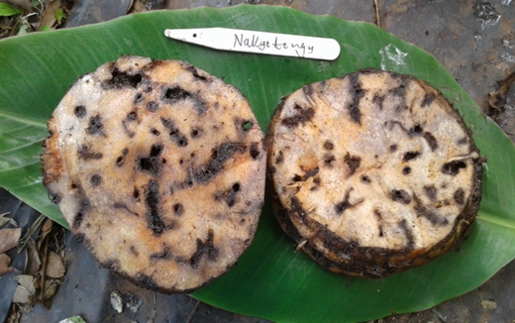
Figure 2. Cross-sectional damage on the banana corm

Data analysis
- To determine the variation among genotypes, analysis of variance is carried out using the following linear model: Genotype response = μ+ genotype effect + block effect + block/rep effect + error
- Both Dunnett’s test and fishers protected least significate different test using GenStat or any other powerful statistical package are used to separate the resistant genotypes from susceptible genotypes with comparison to the positive and negative checks.

References
Frison EA. 1999. Integrated pest management: An overview. In: Mobilization of IPM for sustainable banana production in Africa.Frison EA, Gold CS, Karamura EB, Sikora RA (eds) Proceedings of a workshop on banana IPM held in Nelspruit, South Africa, 23-28 November 1998. INIBAP. Montpellier, France, pp. 9-22.
Gold CS, Messiaen S. 2000. The banana weevil, Cosmopolites sordidus. Musa Pest Fact Sheet No. 4, INIBAP, Montpellier.
Gold CS, Kagezi GH, Night G, Ragama PE. 2004. The effects of banana weevil, Cosmopolites sordidus, damage on highland banana growth, yield and stand duration in Uganda. Annals of Applied Biology, 145(3), pp.263-269.
Gold CS, Ogenga-Latigo MW, Tushemereirwe W, Kashaija I, Nankinga C. 1993. Farmer perceptions of banana pest constraints in Uganda: Results from a rapid rural appraisal. Ibadan, Nigeria: Biological and Integrated Control of Highland Banana and Plantain.
Gold CS, Pena JE, Karamura EB. 2001. Biology and integrated pest management for the banana weevil Cosmopolites sordidus (Germar)(Coleoptera: Curculionidae). Integrated Pest Management Reviews, 6(2), pp.79-155.
Kiggundu A. 2000. Host plant reactions and resistance mechanisms to banana weevil, Cosmopolites sordidus (Germar) in Ugandan Musa germplasm. MSc Thesis, Orange Free State University, South Africa.
Masanza M. 2003. Effect of crop sanitation on banana weevil Cosmopolites sordidus (Germar) populations and associated damage (Doctoral dissertation, Wageningen University and Research Centre, the Netherlands).
Mitchell GA. 1980. Banana Entomology in the Windward Islands: Final report, 1974-1978. Centre for Overseas Pest Research, London.
Padmanaban B, Sathiamoorthy S. 2001. The banana stem weevil Odoiporus longicollis. Inibap. Musa Pest Fact Sheet No.5.
Rukazambuga NDTM, Gold CS, Gowen SR. 1998. Yield loss in East African highland banana (Musa spp., AAA-EA group) caused by the banana weevil, Cosmopolites sordidus Germar. Crop Protection, 17(7), pp.581-589.
Rukazambuga NDTM, Gold CS, Gowen SR, Ragama P. 2002. The influence of crop management on banana weevil, Cosmopolites sordidus (Coleoptera: Curculionidae) populations and yield of highland cooking banana (cv. Atwalira) in Uganda. Bulletin of Entomological Research, 92(5), pp.413-421.
Sadik K, Nyine M, Pillay M. 2010. A screening method for banana weevil (Cosmopolites sordidus Germar) resistance using reference genotypes. African Journal of Biotechnology, 9(30), pp.4725-4730.
Sengooba T. 1986. Survey of banana pest problem complex in Rakai and Masaka Districts in Uganda. Namulonge, Uganda: Namulonge Research Station.
Tinzaara W, Kiggundu A, Gold CS, Tushemereirwe WK, Karamura EB. 2009. Management options for highland banana pests and diseases in East and Central Africa. Outlooks on Pest Management, 20(5), p.204.

